CHAPTER-1

LAN, MAN, and WAN

2.1 Origin of the Internet
As we see the history of the computer system, first the mainframe computers were popular for the organizational task, where the main facilities are the message passing, resource sharing & concurrent operation on the single job or problem as there is single work station for multiple interfaces. As the technology goes forward, the mainframe is replaced by PC as they have low cost, high processing speed & smaller size. But the adoption of PCs losses the facilities provided by the mainframe and hence the concept of computer network arises with many research.

A network is a group of connected communicating devices such as computers and printers. An internet (note the lowercase letter i) is two or more networks that can communicate with each other. The most notable internet is called the Internet (uppercase letter I), a collaboration of more than hundreds of thousands of interconnected networks. Private individuals as well as various organizations such as government agencies, schools, research facilities, corporations, and libraries in more than 100 countries use the Internet. Millions of people are users. Yet this extraordinary communication system only came into being in 1969.

In 1967, Advanced Research Projects Agency (ARPA) presented its ideas for ARPANET, a small network of connected computers. The idea was that each host computer (not necessarily from the same manufacturer) would be attached to a specialized computer, called an interface message processor (IMP). The IMPs, in turns, would be connected to one another. Each IMP had to be able to communicate with other IMPs as well as with its own attached host.

Shortly thereafter, authorities made a decision to split TCP into two protocols: Transmission Control Protocol (TCP) and Internetworking Protocol (IP). IP would handle datagram routing while TCP would be responsible for higher-level functions such as segmentation, reassembly, and error detection. The internetworking protocol became known as TCP/IP.

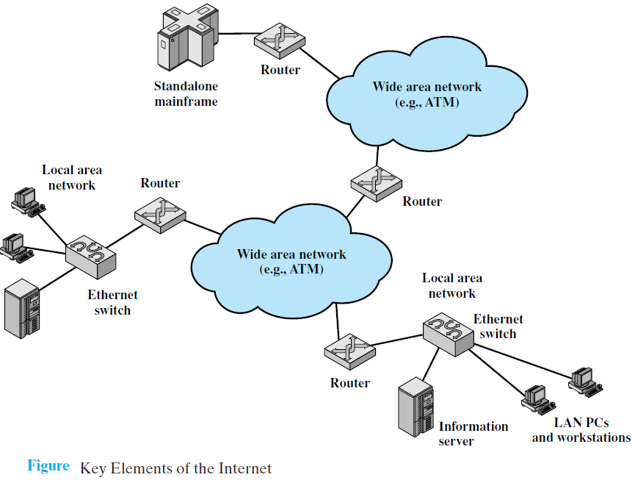
2.2 Internet Architecture
The Internet today is not a simple hierarchical structure. It is made up of many wide- and local-area networks joined by connecting devices and switching stations. Today most end users who want Internet connection use the services of Internet service providers (ISPs). There are international service providers, national service providers, regional service providers, and local service providers. The Internet today is run by private companies, not the government.

The purpose of the Internet, of course, is to interconnect end systems, called hosts; these include PCs, workstations, servers, mainframes, and so on. Most hosts that use the Internet are connected to a network, such as a local area network (LAN) or a wide area network (WAN). These networks are in turn connected by routers. Each router attaches to two or more networks. Some hosts, such as mainframes or servers, connect directly to a router rather than through a network.

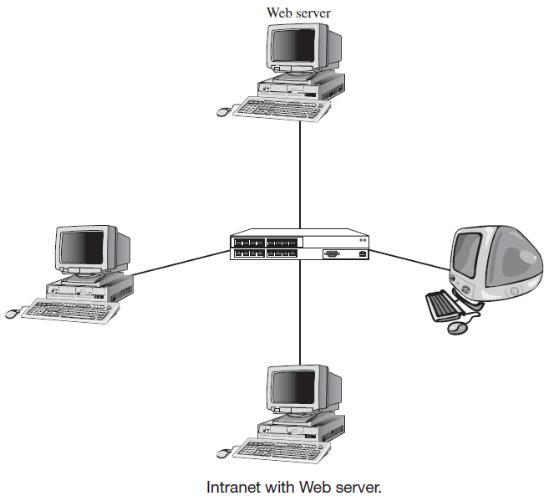
In essence, the Internet operates as follows. A host may send data to another host anywhere on the Internet. The source host breaks the data to be sent into a sequence of packets, called IP datagrams or IP packets. Each packet includes a unique numeric address of the destination host. This address is referred to as an IP address, because the address is carried in an IP packet. Based on this destination address, each packet travels through a series of routers and networks from source to destination. Each router, as it receives a packet, makes a routing decision and forwards the packet along its way to the destination.

2.3 Intranet
Intranet is a private internal computer network (typically a LAN) that uses Internet Protocol technology to securely share part or all of an organization’s information with its authorized users. It often consists of a web interface used to distribute notices, announcements, and appropriate internal proprietary information.

Sometimes it includes a mix of private and public access. For example, although some pages on a web server may be open to the public and accessible by anyone on the Internet, some pages may be on an intranet and therefore hidden from those who connect to the web server from the Internet by hiding behind any security system such as firewall. Sometimes an intranet uses a completely separate web server hidden from the Internet.

2.4 Extranet
The extranet is same as an intranet but it makes the system more secure using the Hypertext Transfer Protocol Secure (HTTPS) for accessing some resources by some specific groups inside or outside the organization. The interior groups may be any business partners, administrative officers and the outside user may be any customers which want to make any transition on his account etc.

It can provide access to information services, inventories, and other internal organizational databases that are provided only to customers, suppliers, or those who have paid for access. Typically, users are given passwords to gain access, but more sophisticated technologies such as smart cards or special software may also be required. Many universities provide extranets for web-based courses so that only those students enrolled in the course can access course materials and discussions.

2.5 Categories of Networks
The category into which a network falls is determined by its size. A Personal Area Network (PAN) let devices communicate over the range up to one square meter. A Local Area Network (LAN) normally covers an area less than 2 miles; a Wide Area Network (WAN) can be worldwide. Networks of a size in between are normally referred to as Metropolitan Area Networks (MAN) and span tens of miles. It should be noted that, for planet to planet communication with range above 10,000 KM, the Global Area Network (GAN) is used.

2.5.1 Personal Area Network (PAN)
PANs let devices communicate over the range of a person. A common example is a wireless network that connects a computer with its peripherals. Almost every computer has an attached monitor, keyboard, mouse, and printer. Without using wireless, this connection must be done with cables. So many new users have a hard time finding the right cables and plugging them into the right little holes (even though they are usually color coded) that most computer vendors offer the option of sending a technician to the user’s home to do it. To help these users, some companies got together to design a short-range wireless network called Bluetooth to connect these components without wires. The idea is that if your devices have Bluetooth, then you need no cables. You just put them down, turn them on, and they work together.
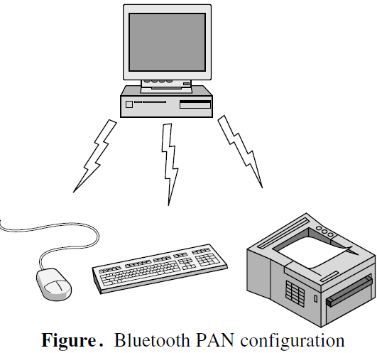
In the simplest form, Bluetooth networks use the master-slave paradigm as shown in figure. The system unit (the PC) is normally the master, talking to the mouse, keyboard, etc., as slaves. The master tells the slaves what addresses to use, when they can broadcast, how long they can transmit, what frequencies they can use, and so on. The Bluetooth is often used to connect a headset to a mobile phone without cords and it can allow your digital music player to connect to your car merely being brought within range. A completely different kind of PAN is formed when an embedded medical device such as a pacemaker, insulin pump, or hearing aid talks to a user-operated remote control.

2.5.2 Local Area Network (LAN)
A local area network (LAN) is usually privately owned and links the devices in a single office, building, or campus. Depending on the needs of an organization and the type of technology used, a LAN can be as simple as two PCs and a printer in someone's home office; or it can extend throughout a company and include audio and video peripherals. When LANs are used by companies, they are called enterprise networks. Due to limitations in distance, performance, and manageability, a LAN is usually confined to a single office or floor of a building.
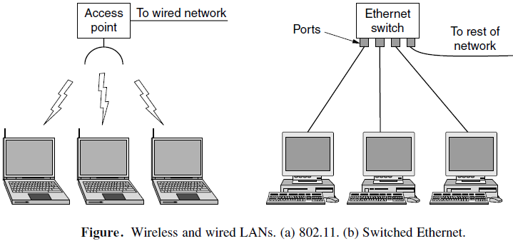

In general, a given LAN will use only one type of transmission medium. The most common LAN topologies are bus, ring, and star. Currently, LAN size is limited to a few kilometers. Early LANs had data rates in the 4 to 16 megabits per second (Mbps) range. Today, however, speeds are normally 100 or 1000 Mbps. Devices on a wired LAN are connected using inexpensive cable.

Local area networks (LANs) play an important part in the everyday functioning of schools, businesses, and government. LANs save people time, lower equipment costs by centralizing printers and other resources, and allow sensitive information to remain in a secure location. Recently, LANs have been used as tools to improve collaboration between employees and for job training using audio and video.
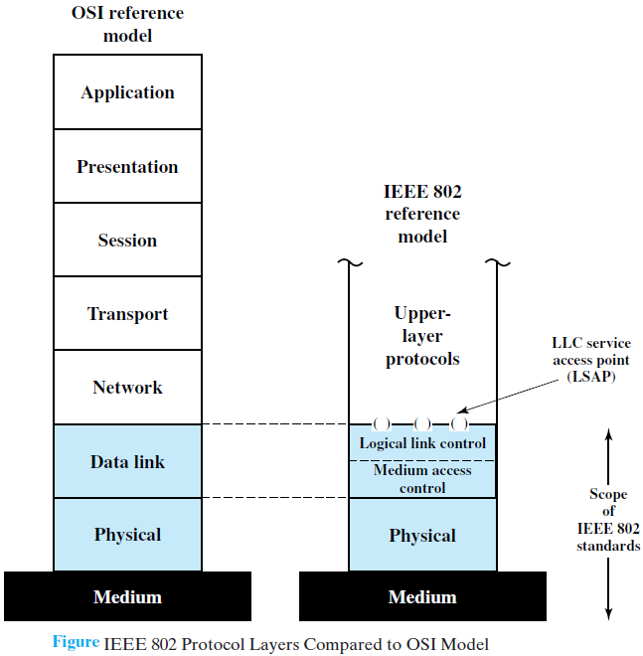

Wireless LAN (Wi-Fi)
Wireless Fidelity (Wi-Fi) is a set of technologies standards (IEEE 802.11a, b, g, n, p) for wireless LAN (WLAN). The Wi-Fi was first standardized in 1997 (IEEE 802.11) and then first revised in 1999 (IEEE 802.11a). After that the Wi-Fi has gone with several changes to deploy the fixed broadband wireless networks in more efficient manner. The Wi-Fi was basically designed for short-range (300 feet) operations and basically the indoor technology. It is a wireless line-of-sight (LOS) technology that basically has following merits and demerits compared to that of wired networks:

Advantages
- Mobility: Enable users to physically move while using an appliance
- Cost Saving: Quick to set up, reliability due to less used cables, no wiring difficulties like a historical museum building, low power for battery use, simple management, security, privacy, safety (low radiation)
- More robust against disasters like earthquakes, fire
- Ad-hoc networks without previous planning possible
- No special permissions or licenses needed
- There are many Wi-Fi compatible products that are available at a low cost and can interoperate with other network technologies.

Disadvantages
- Very low bandwidth compared to wired networks
- Interference limited system
- Limited level of mobility compared to that of modern technology
- Security is a concern
- Problem of hidden node and exposed node, near and far terminals problem

Architecture
Architecture is designed to support a network where mobile station is responsible for the decision making. The Wi-Fi system can be described with ad-hoc network and infrastructure network. The main components of infrastructure networks are:
- Station (STA): It is a terminal with access mechanisms to the wireless medium and radio contact to the access point. Supported services to STA are authentication, privacy, and delivery of the data.
- Access Point (AP): Similar to the base station in cellular network that supports range extension by providing network connectivity between multiple BSSs.
- Basic service set (BSS): It is a group of stations using the same radio frequency on which all stations can directly communicate with each other, without any infrastructure. Multiple BSSs are connected together through a Distribution System (DS).
- Distribution System: DS is similar to a backbone network like Ethernet-based LAN. BSSs connected by a DS form an Extended Service Set (ESS).
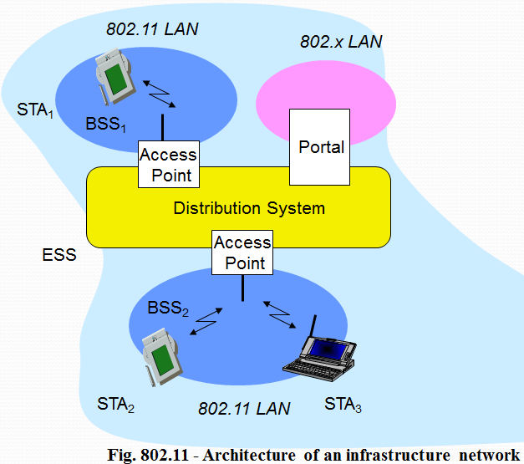
- Portal: Bridge to other (wired) networks

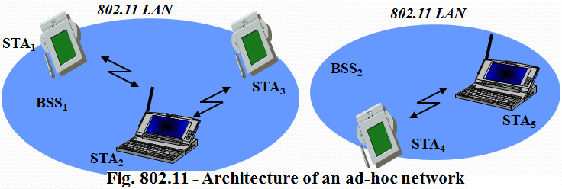

2.5.3 Metropolitan Area Network (MAN)
A metropolitan area network (MAN) is a network with a size between a LAN and a WAN, typically spanning up to 75 miles. It normally covers the area inside a town or a city. It is designed for customers who need a high-speed connectivity, normally to the Internet, and have endpoints spread over a city or part of city. A good example of a MAN is the part of the telephone company network that can provide a high-speed DSL line to the customer. Another example is the cable TV network that originally was designed for cable TV, but today can also be used for high-speed data connection to the Internet.
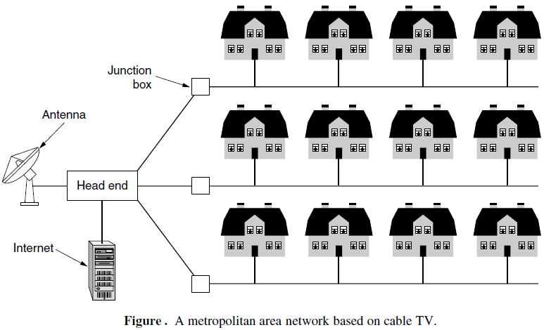
MANs are popular as a way of allowing local governments to share valuable resources, communicate with one another, and provide a large-scale private phone service. MANs are also appealing to fairly large regional businesses that want to connect their offices for the same reasons. Although MANs are very expensive to implement, they offer a high-speed alternative to the slower connections often found in WANs because of the MANs’ higher-performance cable plant and equipment.

Recent developments in high speed wireless Internet access have resulted in another MAN, which has been standardized as IEEE 802.16 and is popularly known as Worldwide Interoperability for Microwave Access (Wi-MAX).
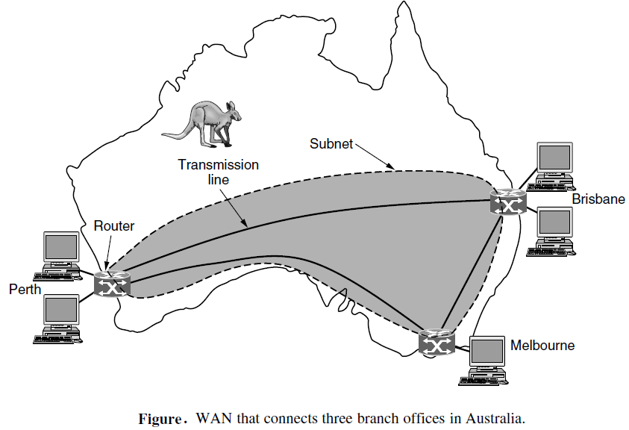

2.5.4 Wide Area Network (WAN)
A wide area network (WAN) provides long-distance transmission of data, image, audio, and video information over large geographic areas that may comprise a country, a continent, or even the whole world.

A WAN can be as complex as the backbones that connect the Internet or as simple as a dial-up line that connects a home computer to the Internet. We normally refer to the first as a switched WAN and to the second as a point-to-point WAN. The switched WAN connects the end systems, which usually comprise a router (internetworking connecting device) that connects to another LAN or WAN. An early example of a switched WAN is X.25, asynchronous transfer mode (ATM) and the wireless WAN that is becoming more and more popular. The point-to-point WAN is normally a line leased from a telephone or cable TV provider that connects a home computer or a small LAN to an Internet service provider (ISP). This type of WAN is often used to provide Internet access. WANs have the following characteristics:
- They can cover a very large geographical area—even span the world.
- They usually communicate at slower speeds (compared to LANs).
- Access to the WAN is limited—a LAN usually has only one WAN link that is shared by multiple devices.
- They use devices such as routers, modems, and WAN switches, connectivity devices specific to LANs and used to connect to long-haul transmission media.

NOTE: Transmission Technology
    - Unicast Network (point-to-point links)
Point-to-point links connect individual pairs of machines. To go from the source to the destination on a network made up of point-to-point links, short messages, called packets in certain contexts, may have to first visit one or more intermediate machines. Often multiple routes, of different lengths, are possible, so finding good ones is important in point-to-point networks. Point-to-point transmission with exactly one sender and exactly one receiver is sometimes called unicasting.

    - Broadcast Network
In contrast, on a broadcast network, the communication channel is shared by all the machines on the network; packets sent by any machine are received by all the others. An address field within each packet specifies the intended recipient. Upon receiving a packet, a machine checks the address field. If the packet is intended for the receiving machine, that machine processes the packet; if the packet is intended for some other machine, it is just ignored. A wireless network is a common example of a broadcast link, with communication shared over a coverage region that depends on the wireless channel and the transmitting machine.

